“SHUT THE LID” DUMPSTER PROGRAM

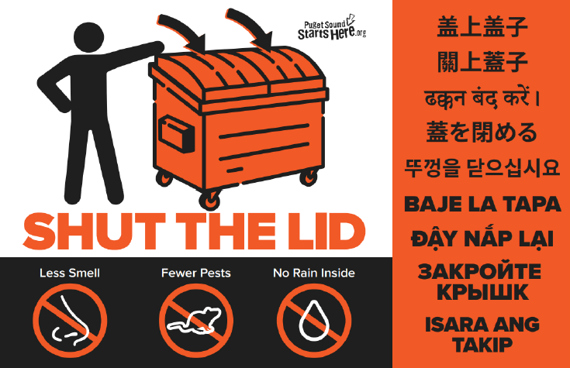

The City of Snohomish would like to place a “SHUT THE LID” sticker on your dumpsters to remind users to shut the lid every time you take out your garbage and recycling. Properly closing the lid on a dumpster reduces smells, pests, and keeps rain out.

Why is this important?
Open dumpsters can cause pollution problems for streams and lakes. When a dumpster lid is left open, rainwater gets in, and then dumpster juice can leak from a dumpster or pour out when it is emptied into a garbage truck. Sometimes, it even leaks from the garbage truck. The dumpster juice pollutes the waters when it gets washed into the nearest storm drain and flows into the receiving waters such as Blackmans Lake, Pilchuck River, and Snohomish River.

We would like to meet with you to discuss the “Shut the Lid” Dumpster Program and pollution prevention.
Please contact Dan Hotovitsky at 360-913-4479 or hotovitsky@snohomishwa.gov to schedule a meeting. If a meeting is not scheduled in advance, Dan will stop by when he is in your neighborhood.

We look forward to being partners in helping protect and improve local water quality.

Thank you for your cooperation,
Dan Hotovitsky
City of Snohomish
NPDES Program Coordinator

